**ASSIGNMENT-02**

**DATA VISUALIZATION AND PRE PROCESSING**

| **Assignment Date** | 30 September 2022 |
| --- | --- |
| **Student Name** | Mirudhula SV |
| **Student Roll Number** | 113219071020 |
| **Maximum Marks** | 1. Marks |

1. Download the dataset

2.Load the dataset into the tool



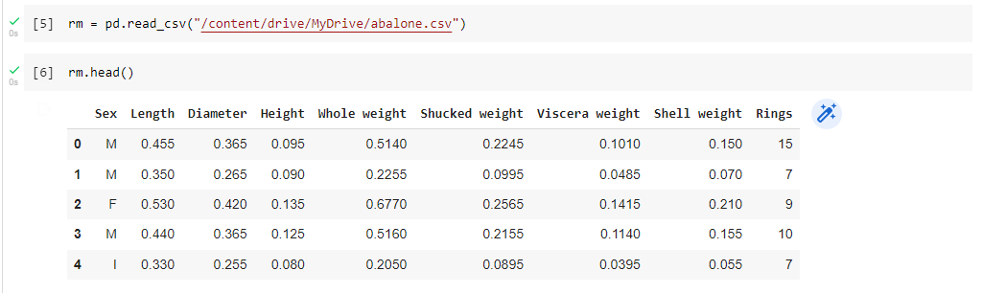

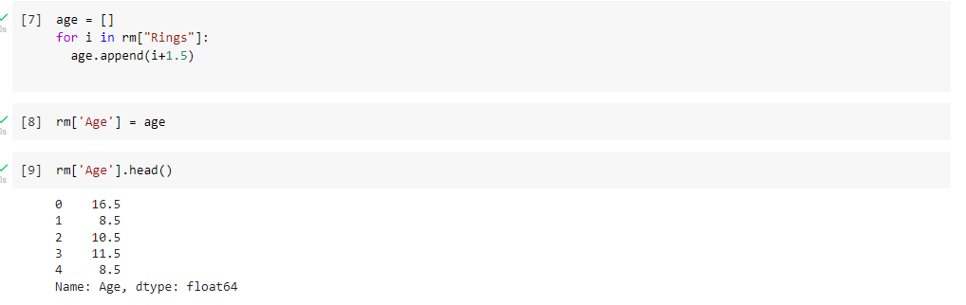

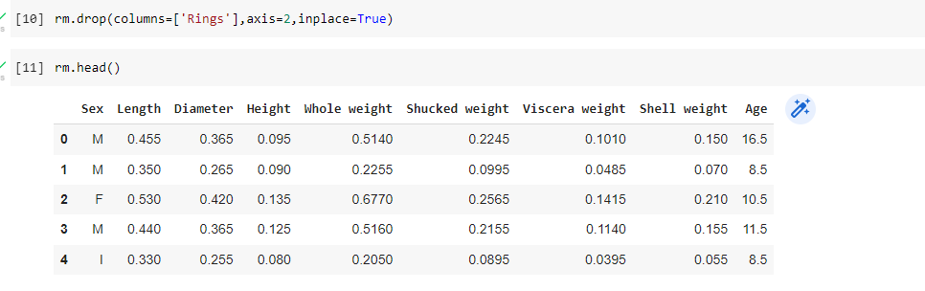

3.Perform Below Visualizations.

* Univariate Analysis

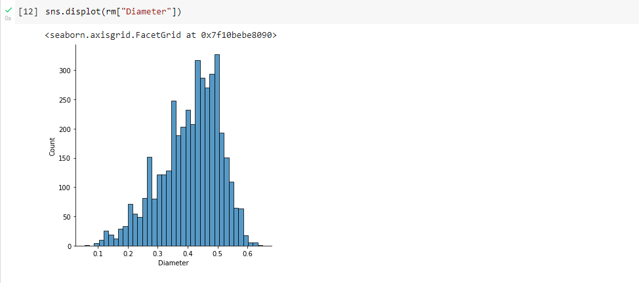

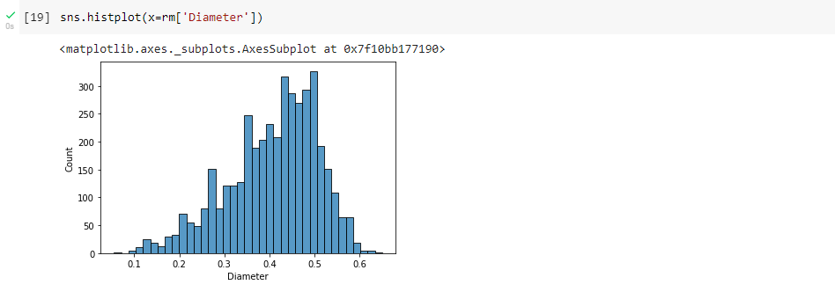

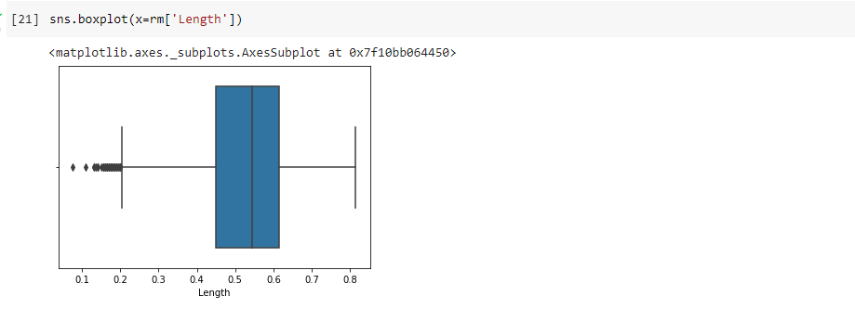

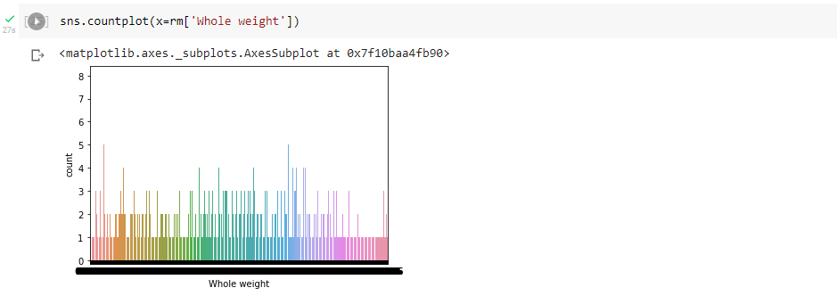

* Bi - Variate Analysis

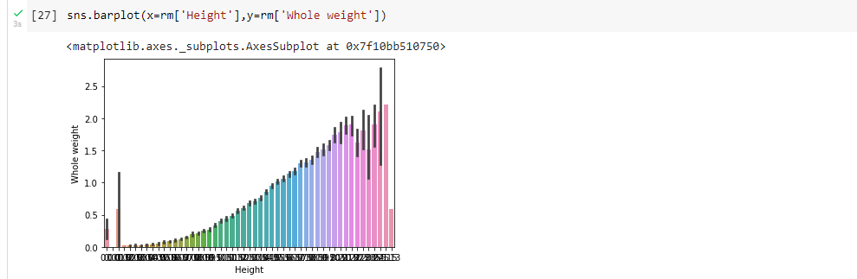

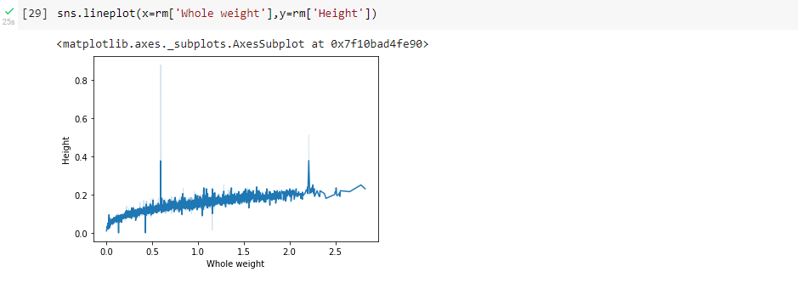

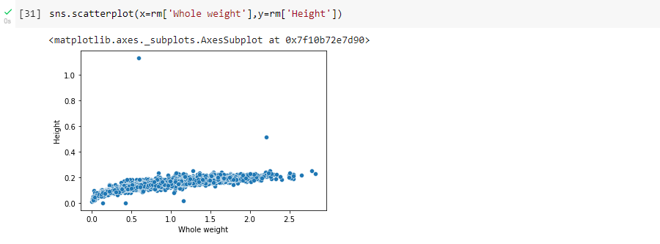

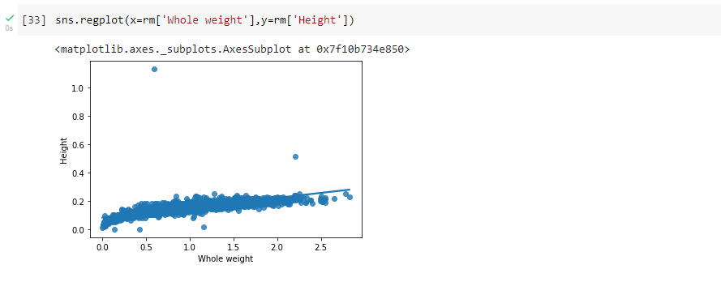

* Multi - Variate Analysis



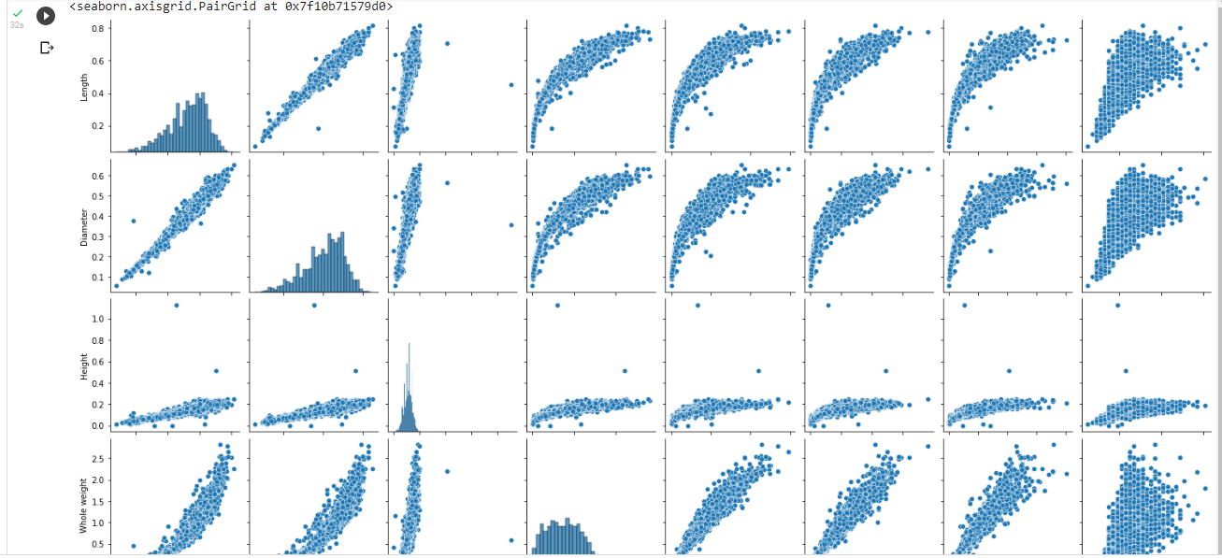

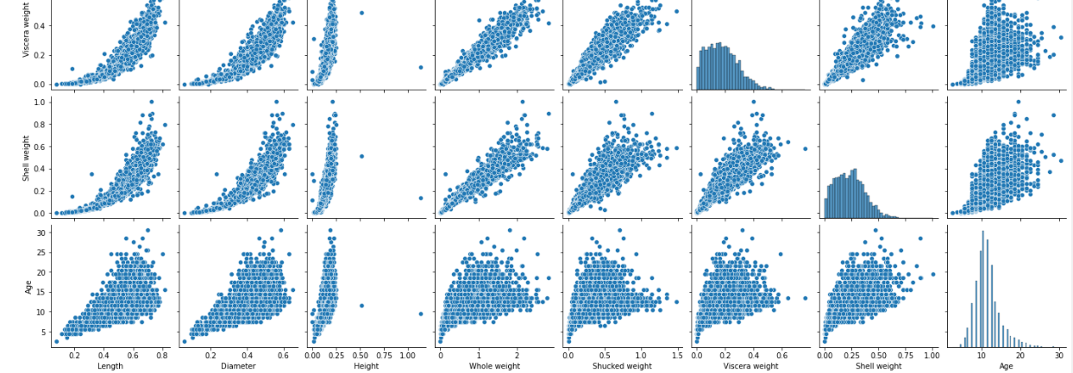

4. . Perform descriptive statistics on the dataset.

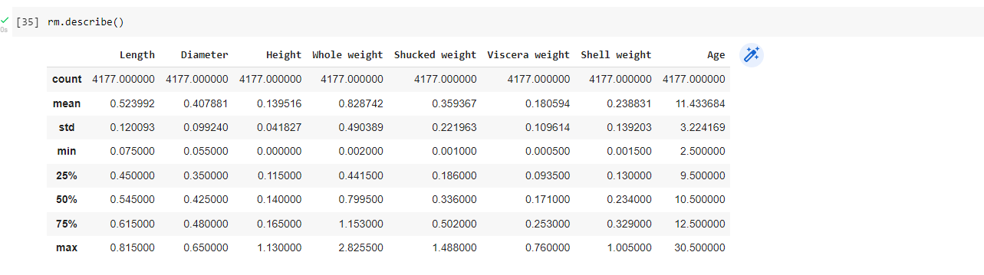

5. Check for Missing values and deal with them.

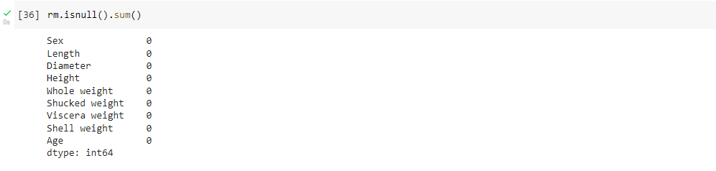

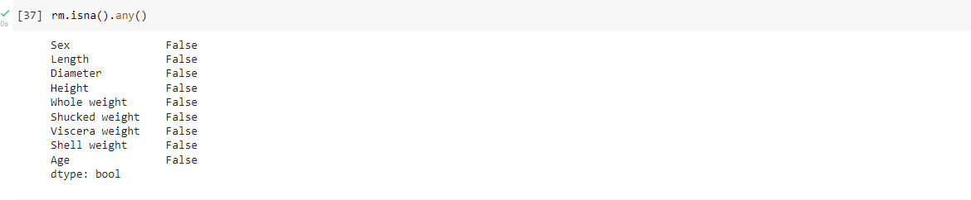

6. Find the outliers and replace them outliers

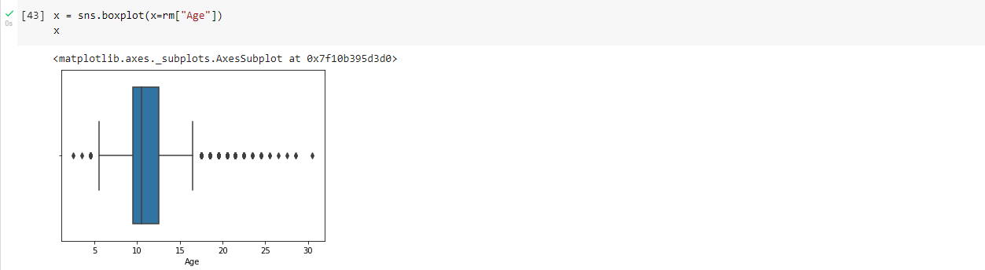

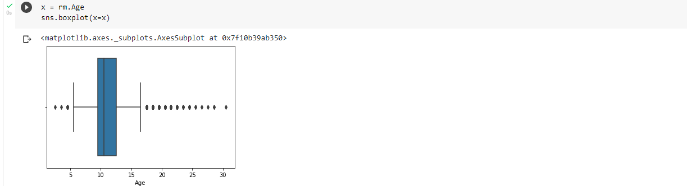

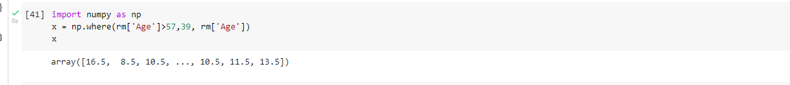



7. Check for Categorical columns and perform encoding

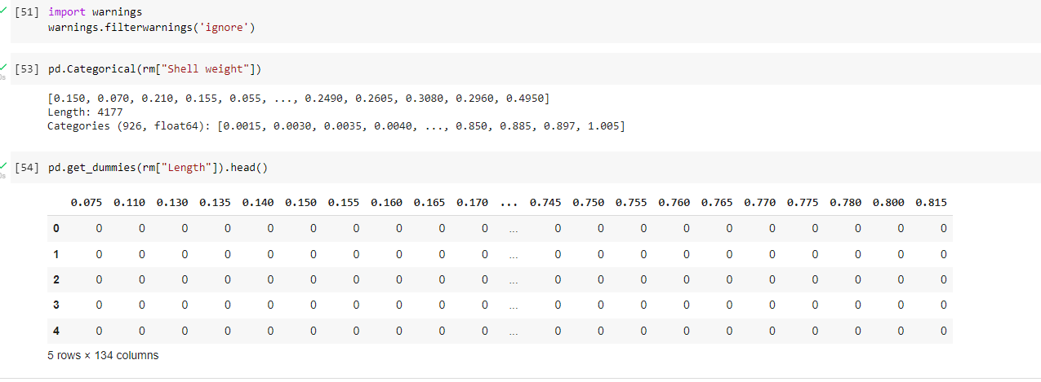

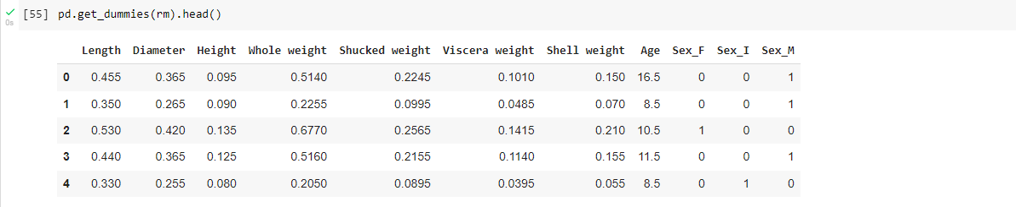

8.Split the data into dependent and independent variables

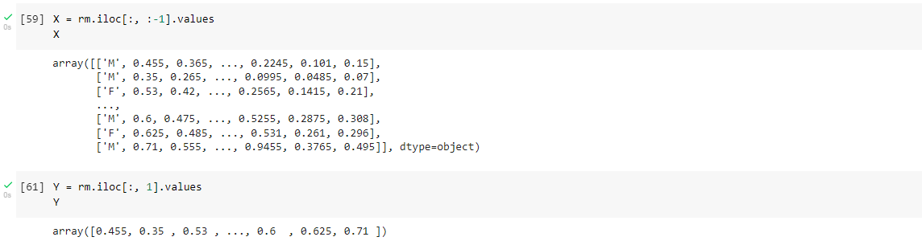

9. Scale the independent variables

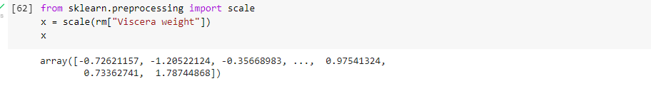

10. Split the data into training and testing

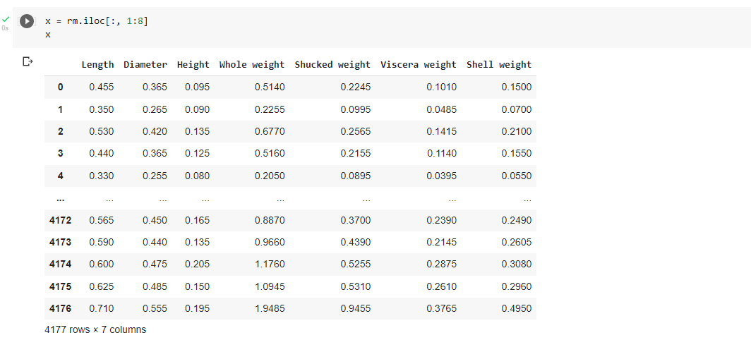

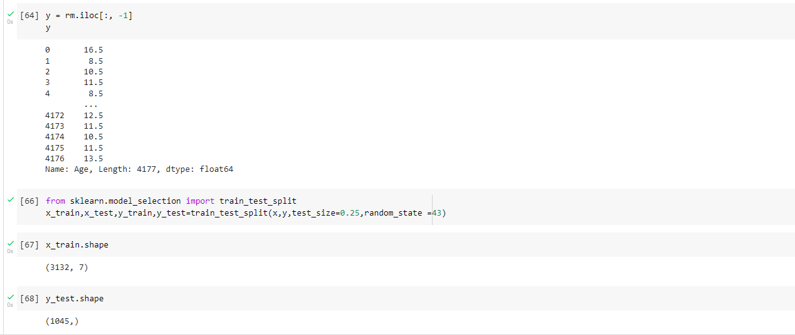

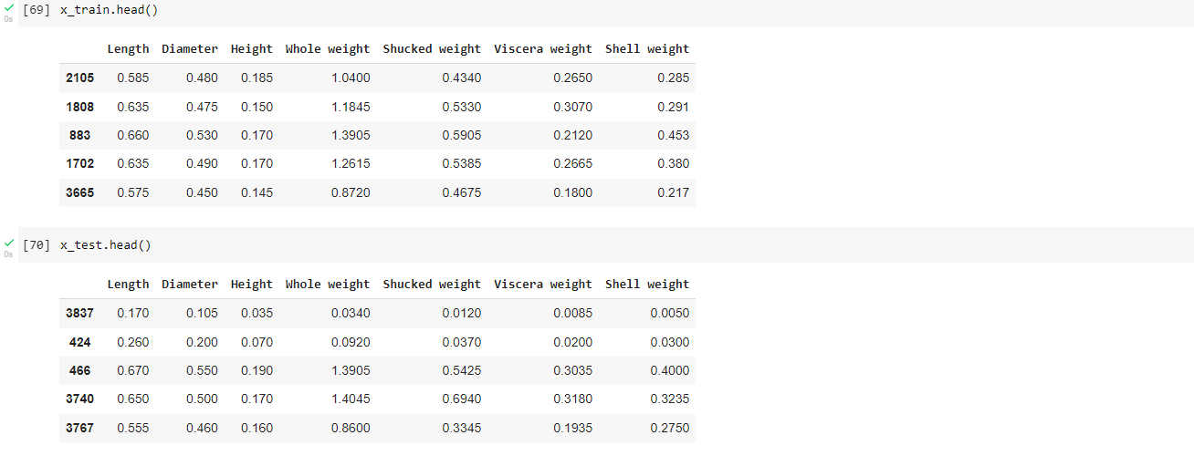

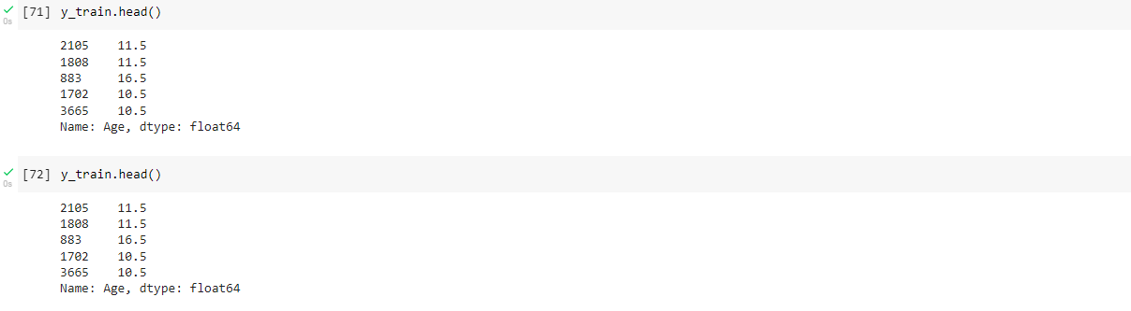

11. . Build the Model

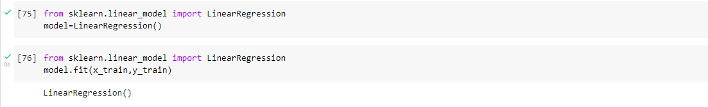

12. Train the Model



13 . Test the Model

